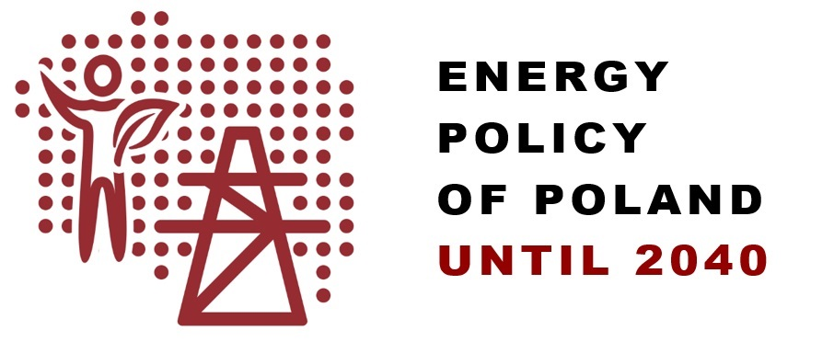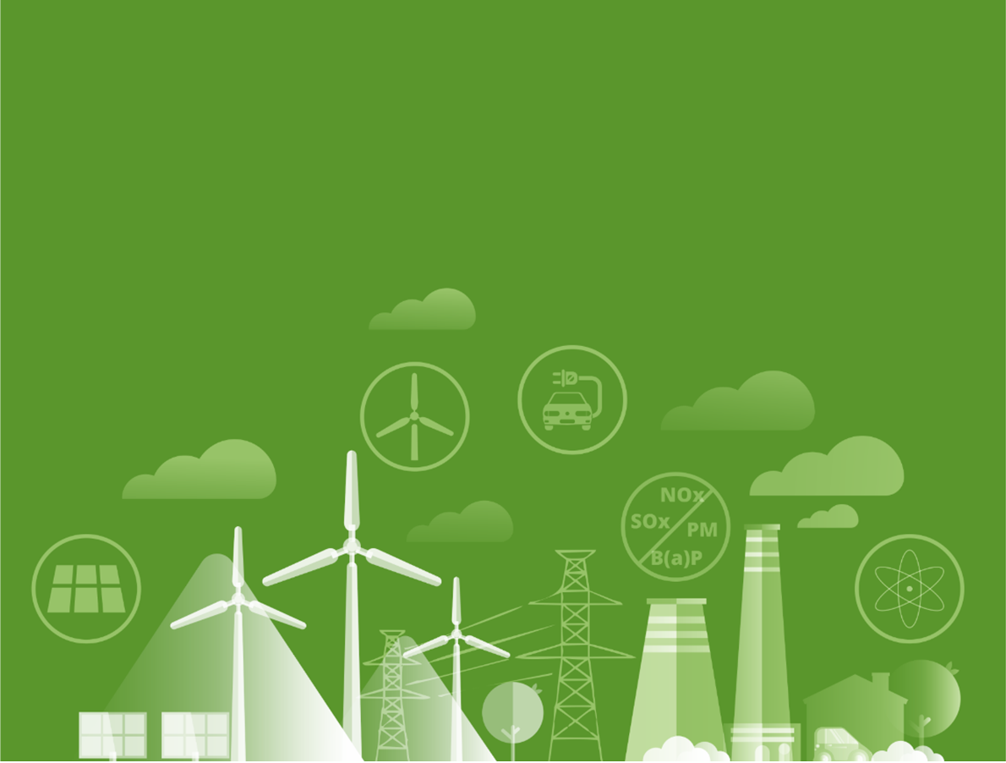

Extract

# Table of contents

1. Introduction 2

2. Summary 5

3. The three pillars of the energy transition 6

4. Key elements of PEP2040 9

5. The goal of the state's energy policy 10

6. Specific objectives of PEP2040 12

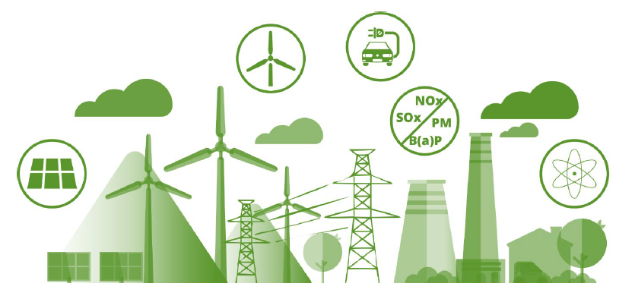

# Introduction

Shaping the national energy strategy if strongly affected by the **European Union’s (EU) climate and energy policy**, including its long-term vision of striving for EU climate neutrality by 2050 and the regulating mechanisms stimulating the achievement of effects in the coming decades. Meeting the EU's climate and energy objectives for 2020 and 2030 is key to a low-emission energy transition. Following the EU's decarbonisation ambition, in December 2020, the European Council approved a binding EU objective to reduce net greenhouse gas emissions by at least 55% by 2030, compared to 1990 emissions. This increased the previously binding 40% reduction target. The new EU's ambition is defined as a collective target for the whole Union, i.e. implemented on the basis of Member States' contributions, taking into account national considerations, specific starting points, reduction potential, the principle of sovereignty in shaping the national energy mix, the need to guarantee energy security; in the most cost-effective manner possible, to maintain affordable energy prices for households and the EU’s competitiveness; as well as taking account of the principle of equity and solidarity. Following the UE’s dynamically accelerating climate and energy trends will be a significant transition challenge for Poland.

The targets specified for 2020 are the reference point on the path of the long-term energy transition.

A package of regulations was adopted in 2009, setting three fundamental targets to counteract climate change by 2020 (the so-called 3 x 20% package), with Member States participating in accordance with their capabilities. Poland is obliged to:

* increase energy efficiency by saving 13.6 Mtoe of primary energy consumption over the 2010-2020 period compared to the fuel and energy demand forecast from 2007;
* increase the share of RES energy in gross final energy consumption to 15% by 2020;
* contribute to an EU-wide reduction of greenhouse gas emissions by 20% (compared to 1990) by 2020 (in terms of 2005 levels: -21% in EU ETS sectors and -10% in non-ETS sectors).

In 2014, the European Council maintained the direction of counteracting climate change and approved four targets for the 2030 perspective for the entire EU, which, after 2018 and 2020 revision, have the following shape:

* reduction of greenhouse gas (GHG) emissions by at least 55% compared to 1990 emissions;
* at least 32% share of renewable sources in the gross final energy consumption;
* increase in energy efficiency by 32.5%;
* completing the establishment of the EU’s internal energy market.

These targets are the EU's contribution to the implementation of climate agreements. Key importance to current policy and action has the so-called **Paris Agreement**, concluded in December 2015 at the 21st Conference of the Parties to the *United Nations Framework Convention on Climate Change* (COP21). It indicates the need to stop the increase in global average temperature at less than 2°C in relation to the levels of pre-industrial era, and efforts should be made to keep it at no more than 1.5°C. During the 24th Conference (COP24), in December 2018, during the Polish Presidency, the so-called Katowice Climate Package implementing the Paris Agreement was signed. Particular attention was given to the fact that the *transition* resulting from the Paris Agreement must take place in a just and solidary manner.

In 2019, the EU's work over the *Clean Energy for All Europeans* regulation package was completed, the package indicating how to operationalise the EU's climate and energy targets for 2030 and intended to contribute to the **implementation of the Energy Union** and the **establishment of a single EU energy market**. The Polish government took an active part in shaping the final wording of the regulations as they strongly affect the functioning and defining the future of the energy market model in Poland.

The outlook assumes further revision of the key EU regulations concerning the energy sector, which will refer to the targets and tools of the European Union's energy and climate policy in a time horizon that goes beyond 2030. This applies in particular to the decisions on the long-term vision for reducing greenhouse gas emissions in the EU by 2050. For this reason, the outlook after 2030 has been defined directionally, even though the forecasts made for PEP2040 have an outlook for 2040 as required by law.

In 2019, the European Commission published a communication on the **European Green Deal**, i.e. a strategy whose ambitious goal is for the EU to achieve climate neutrality by 2050 – as a global leader in this area. Poland supported this goal, but developed a specific national derogation due to the difficult starting point of the Polish transition and its social and economic aspects. Poland has made great progress in reducing the environmental impact of its energy sector over the past several years, in particular by modernising its generation capacity and diversifying its energy generation structure. However, our dependence on carbon fuels is still much higher than that of other EU Member States, and that is why a ***just transition*** is so important to us, which means taking into account the starting point, the social context of the transition, and counteracting the uneven distribution of costs between countries, more burdensome for economies with a high use of carbon fuels. It must be emphasised that the costs relate to both coal regions (mining and power) and entire economies, which in the short term incur expenditures on new capacity, often also on economically immature, more expensive technologies, power grid infrastructure, which is also reflected in the price of energy.

**A coronavirus pandemic** hit the world in 2020, affecting all global economies. This emergency situation has also revealed the important role of the energy sector, including energy security, for the functioning of the economy of Poland and other European countries. In the coming years, the energy sector will face a number of post-COVID challenges related to, among others, rebuilding or substituting supply chains in order to conduct investments, mobilising financial resources in budgets strained by the effects of the epidemic, and sometimes – revising investment plans and accumulating resources for key undertakings. It is important that investment decisions are made taking into account the aspect of green and low-emission economic recovery. Recovery actions after the pandemic are aimed to **provide a quick and effective growth boost** and create new opportunities for the national economy. In addition to the protective tools and measures mobilising domestic public resources, also EU support will be used.

The energy transition will require the involvement of many entities and incurring considerable investment outlays[1], the scale of which in the years 2021-2040 may reach approx. PLN 1,600 billion. Investments in the fuel and energy sectors will involve financial resources of approx. PLN 867-890 billion. The estimated outlays in the electricity generation sector will amount to approx. PLN 320-342 billion, of which approx. 80% will be allocated to zero-emissions units, i.e. RES and nuclear power. As a result of the above mentioned deep transition of the fuel and energy sector, energy costs may increase. A number of investments can receive financial support (operational and investment), resulting in changes happening as quickly as possible and on a larger scale. It is important that the manner in which the transition is carried out ensures socially acceptable energy prices and does not deepen energy poverty.

Around PLN 260 billion from the EU and national funds under various mechanisms will be allocated to the national energy and climate transition until 2030[2], including:

* 1. *Cohesion Policy* (approx. PLN 79 billion[3]),
  2. *Recovery and Resilience Facility* (approx. PLN 97.8 billion[4]),
  3. *Just Transition Fund* (allocation for Poland of approx. PLN 15.6 billion),
  4. *React-EU* (approx. PLN 1.8 billion[5]),
  5. Other facilities (e.g. priority programmes of the National Fund for Environmental Protection and Water Management and funds of the Common Agricultural Policy of approx. PLN 20 billion).
  6. New instruments which will support the energy system transition in Poland, e.g. the Modernisation Fund and the national earmarked fund funded from the sale of CO2 emission allowances, i.e. the Energy Transition Fund (for which preliminary estimates indicate over PLN 47.6 billion[6]).

# Summary

*Energy Policy of Poland until 2040* (PEP2040) sets the framework for the energy transition in Poland. It contains strategic decision regarding the selection of technologies used to establish a low-emission energy system. PEP2040 contributes to the implementation of the *Paris Agreement* concluded in December 2015 at the 21st Conference of the Parties to the *United Nations Framework Convention on Climate Change* (COP21), taking into account the need to achieve the transition in a just and solidary manner. PEP2040 is a national contribution to the EU's climate and energy policy, whose ambition and dynamism have increased significantly in recent times. The policy takes into account the scale of the challenge of adapting the domestic economy to EU regulatory considerations related to the 2030 climate and energy targets, the European Green Deal, the COVID pandemic recovery plan and the pursuit of climate neutrality in line with national capabilities as a contribution to the Paris Agreement. The low-emission energy transition envisaged in PEP2040 will initiate broader modernisation changes across the economy, guaranteeing energy security, ensuring fair distribution of costs and protecting the most vulnerable social groups.

PEP2040 is one of nine integrated sectoral strategies resulting from the *Strategy for Responsible Development*. PEP2040 is consistent with the *National Energy and Climate Plan 2021-2030*

PEP2040 includes **a description of the status and conditions** of the energy sector. Then, the **three PEP2040 pillars** were identified, on which the **eight PEP2040 specific objectives** were based, along with the **measures** necessary for their implementation, as well as **strategic projects**. A territorial approach was presented and the sources of PEP2040 funding were indicated.

Attached to the document are (1) an assessment of the implementation of the previous state energy policy, (2) conclusions from prognostic analyses and (3) a strategic environmental impact assessment of PEP2040.

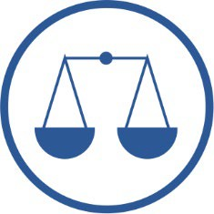I PILLAR

Just transition

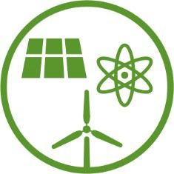II PILLAR

Zero-emission   
energy system

III PILLAR

Good air quality

|  |  |  |
| --- | --- | --- |
| SPECIFIC OBJECTIVE 1.  Optimal use of own energy sources | SPECIFIC OBJECTIVE 2.  Development of electricity generation and network infrastructure | SPECIFIC OBJECTIVE 3.  Diversification of supplies and expansion of the network infrastructure of natural gas, crude oil and liquid fuels |
| STRATEGIC PROJECT 1.  Transition of coal regions | STRATEGIC PROJECT 2A.  Capacity market  STRATEGIC PROJECT 2B.  Implementation of smart power grids | STRATEGIC PROJECT 3A.  Construction of the Baltic Pipe  STRATEGIC PROJECT 3B.  Construction of the second line of the Pomeranian Pipeline |
| SPECIFIC OBJECTIVE 4.  Development of energy markets | | SPECIFIC OBJECTIVE 5.  Implementation of nuclear power |
| STRATEGIC PROJECT 4A.  Implementation of the Action Plan (aimed at increasing cross-border electricity transmission capacity)  STRATEGIC PROJECT 4B.  Gas hub | | STRATEGIC PROJECT 5.  Polish Nuclear Power Programme |
| SPECIFIC OBJECTIVE 6.  Development of renewable energy sources | SPECIFIC OBJECTIVE 7.  Development of district heating and cogeneration | SPECIFIC OBJECTIVE 8.  Improvement of energy efficiency |
| STRATEGIC PROJECT 6.  Implementation of offshore wind energy | STRATEGIC PROJECT 2A.  Development of district heating | STRATEGIC PROJECT 8.  Promotion of the improvement  of energy efficiency |

The statutory goal of the **state's energy policy** is energy security[7], while ensuring the competitiveness of the economy, energy efficiency and reducing the impact of the energy sector on the environment.

The **specific objectives** of PEP2040 cover the entire energy supply chain - from obtaining raw materials, through energy production and supply (transmission and distribution), to the method of its use and sale. Each of the eight specific objectives of PEP2040 contributes to the implementation of three elements of the state energy policy objective and serves Poland's energy transition.

# The three pillars of the energy transition

Through the implementation of the objectives and actions indicated in PEP2040, a low-emission energy transition will be carried out with the active role of end consumers and the involvement of domestic industry, giving a stimulus to the economy, while ensuring energy security, in an innovative and socially acceptable manner, respecting the environment and the climate.

The **energy transition** to be carried out in Poland will be:

* 1. **just** – it will not leave anyone behind,
  2. **participatory**, conducted **locally**, initiated **bottom-up** – everyone will be able to participate in it,
  3. focused on modernisation and **innovation** – it is a plan for the future,
  4. stimulating **economic growth**, **efficiency** and **competitiveness** – it will be the **engine of economic growth**.

The energy transition will be based on three pillars:



|  |  |  |
| --- | --- | --- |
| **I pillar**  Just transition | **II pillar** Zero-emission energy system | **III pillar** Good air quality |
| Transition of coal regions  Reduction of energy poverty  New industries related to renewable energy and nuclear energy | Offshore wind energy  Nuclear energy  Local and civic energy | Heating transition  Transport electrification  Climate-friendly House |

**I. Just transition**

– this means providing new development opportunities for the regions and communities most negatively affected by the low-emission energy transition, while creating new jobs and building new branches of industry that participate in the energy sector transition. Activities related to the transition of coal regions will be supported with funds amounting to approx. PLN 60 billion. In addition to the regional approach, the transition will involve individual energy consumers, who on the one hand will be shielded from the increase in energy prices and on the other hand will be encouraged to actively participate in the energy market. This will ensure that the energy transition is conducted justly and that everyone – even small households – can participate. The transition will use national competitive advantages, create new development opportunities and initiate broad modernisation changes, allowing to create up to 300 thousand new jobs in high-potential industries, in particular related to RES, nuclear power, electromobility, grid infrastructure, digitalisation, thermal modernisation of buildings, etc.

**II. Zero-emission energy system**

– this is a long-term direction in which the energy transition is heading. Decarbonisation of the energy sector will be possible through the implementation of nuclear power and offshore wind energy, increasing the role of distributed and civic power generation, but also through the involvement of industrial energy, while ensuring energy security through transitional use of energy technologies based, among others, on gaseous fuels;

**III. Good air quality**

– this is a goal is one of the most noticeable signs of moving away from fossil fuels; thanks to investments in the district heating sector transition (system and individual), electrification of transport and promotion of passive and zero-emission houses using local energy sources, air quality will visibly improve, which has an impact on the environmental health; the key result of the transition, which will be noticed by every citizen, will be ensuring clean air in Poland.

# Key elements of PEP2040

|  |  |  |  |  |  |  |  |
| --- | --- | --- | --- | --- | --- | --- | --- |
| **Energy transition** taking into account electricity self-sufficiency | | Installed capacity of o**ffshore wind energy**  will reach:  approx. 5.9 GW in 2030  and up to 11 GW in 2040 | | | | | There will be a significant increase in installed **photovoltaic** capacity  approx. 5-7 GW in 2030  approx. 10-16 GW in 2040 |
| Increase in the share of RES in all sectors and technologies. In 2030, the share of renewable energy in gross final energy consumption will be at least 23%   * not less than 32% in electricity  (mainly wind and PV) * 28% in heating (increase by 1.1 pp per year) * 14% in transport (with a large contribution of electromobility) | |
| In 2030, the **share of coal in electricity production** will not exceed 56% | | | The reduction in the use of coal in the economy will take place in a manner ensuring a **just transition** | | |
| **Energy efficiency** will increase – for 2030, a target of 23% reduction of primary energy consumption (compared to PRIMES2007 projection) | TSOe and DSOe investment programmes will be focused on the development of renewable energy sources, **active consumers** and local balancing | | In 2033, the first power unit of **a nuclear power plant** will be launched, with a capacity of approx. 1-1.6 GW  Subsequent units will be implemented every 2-3 years, and the entire nuclear programme involves the construction of 6 units | | | | |
| By 2040, the **heating needs of all households** will be covered by system heat and by zero or low-emission individual sources | **Natural gas** will be a bridge fuel in the energy transition | In 2030, the gas network will be able to transport a mixture containing approx. **10% of decarbonised gases** | | | | The infrastructure of natural gas, crude oil and liquid fuels will be expanded, and the diversification of supply directions will be ensured | |
| A number of activities will be aimed at **improving air quality**, including:   * development of district heating (4-fold increase in the number of effective heating systems by 2030) * low-emission direction of transition of individual sources * (heat pumps, electric heating) * **moving away from burning coal in households**  in cities by 2030, in rural areas by 2040, maintaining the possibility of using smokeless fuel until 2040 * increasing the energy efficiency of buildings * development of low-emission transport, in **particular aiming at zero-emission public transport by 2030** in cities of over 100,000 residents | | | | **Reduction of the phenomenon of energy poverty** to the level of max.  6% of households | | | |
| The most anticipated **development of energy technologies and R&D** investments includes:   * energy storage technologies * smart metering and energy management systems * electromobility  and alternative fuels * hydrogen technologies | | | |
| By 2030, **GHG emissions will be reduced by approx. 30%**  compared to 1990 | | | |

# The goal of the state's energy policy

The goal of the state’s energy policy is:

energy security while ensuring the competitiveness of the economy, energy efficiency and reducing the impact of the energy sector on the environment, with the optimal use of own energy resources.

**Energy security** means meeting the current and future needs of customers for fuels and energy in a technically and economically justified manner, while maintaining the requirements of environmental protection. This means the present and future guarantee of the security of supply of raw material, production, transmission and distribution of energy, i.e. the entire energy chain.

The cost of energy is hidden in every activity and product produced in the economy; therefore, energy prices translate into the **competitiveness of the entire economy**. At the same time, emissions of pollutants from the energy sector **have an impact on the environment**; therefore, creating an energy balance must respect this aspect.

The following indicators were adopted as a global measure of the achievement of the PEP2040 target.

# Specific objectives of PEP2040

|  |
| --- |
| SPECIFIC OBJECTIVE 1.  Optimal use of own energy sources |
| STRATEGIC PROJECT 1.  Transition of coal regions |

Domestic raw material potential creates the possibility to cover the demand for coal and biomass independently, however, the majority of demand for natural gas or crude oil has to be covered by import. Due to finite resources, economic and ecological aspects, the protection of documented mineral deposits as well as rational and economical management of raw materials are of key importance.

The demand for **hard coal** will be covered by own resources and the import-export relation will be complementary. The role of this raw material will be limited. During the evolutionary transition of the Polish energy sector, it is necessary for the Polish mining sector to ensure reliable hard coal supplies at competitive prices. This is why it is necessary to ensure profitability of the sector and rational mining, use and distribution of the raw material.

The demand for **lignite** will be covered by domestic resources, close to the place of its use. Prospective deposits (Złoczew and Ościsłowo) will be secured due to their strategic nature, however, their extraction will depend on the decisions of investors. The prices of CO2 emission allowances, environmental conditions and development of new technologies will play a key role in their management.

Research and development activities should be aimed at searching for innovations to reduce the environmental burden resulting from coal mining and new solutions that contribute to low-emission, efficient and flexible use of the raw material (e.g. gasification, liquid fuels).

For social, economic and environmental reasons, coal regions will be restructured so as to ensure that a **just energy transition** leads to economic reinforcement, leaves no one behind and will serve future generations. This process will be supported by financial instruments under the EU's Just Transition Mechanism, mobilising **support resources** **of PLN 60 billion**. Detailed solutions in this regard will be included primarily in national and territorial plans for a just transition.

The demand for **natural gas and crude oil** will be covered mainly with imported raw materials. Actions will be implemented, aimed at diversification of supply directions and sources. At the same time, search for domestic deposits (also unconventional) will be continued, to replace supply from depleted deposits. Part of the demand for crude oil and natural gas will be diminished by the growing importance of biofuels and alternative fuels (e.g. electricity, LNG, CNG, biomethane, hydrogen).

The demand for **renewable raw materials (biomass)** will be covered as close as possible to the place of generation. Efforts will be made to increase the role of waste biomass in order not to compete with other sectors. The potential accumulated in non-agricultural waste and wastewater should also be used.

|  |
| --- |
| SPECIFIC OBJECTIVE 2.  Development of electricity generation and network infrastructure |
| STRATEGIC PROJECT 2A.  Capacity market  STRATEGIC PROJECT 2B.  Implementation of smart power grids |

The power balance must ensure stability of energy supply and flexibility of operation of the power system, as well as the fulfilment of international obligations and respond to changes in the energy market and global trends. At the same time, only an efficient and sufficiently developed infrastructure will ensure security of energy supply. The development of generation and grid infrastructure will lead to the creation of an almost new power system by 2040, based largely on zero-emission sources.

Poland will strive **to be able to cover its power demand with its own resources**. Domestic coal resources will remain an important element of Poland's energy security, but an increase in demand will be covered by sources other than conventional coal-fired units. The share of coal in the energy consumption structure will reach less than 56% in 2030, and with increased prices of CO2 emission allowances it may even fall to the level of 37.5%. **Renewable sources** will play an increasingly important role – their level in the structure of net national electricity consumption will reach no less than 32% in 2030, which will primarily enable the development of photovoltaics and offshore wind farms, which due to economic and technical conditions have the greatest prospects for development. In order to achieve such a level of RES in the balance, it is necessary to develop **grid infrastructure**, **energy storage technologies**, as well as to expand the use of **gas units** as regulating capacity. In 2033, **nuclear power** will be implemented (a total of 6 nuclear power units with a total capacity of 6-9 GW will be built), which will strengthen the base of the system and reduce emissions from the sector. Also in order to **reduce** pollutant **emissions** from the energy sector, low-efficiency generation units will be gradually phased out and replaced with higher-efficiency units (including cogeneration units). With a view **to 2040, an almost new power system will be built** with a strong base of low- and zero-emission

sources.

**The development of the transmission infrastructure** will allow to connect the existing and new sources (including wind and nuclear power) to the grid and to improve power supply security, as well as to increase cross-border exchange opportunities, while preserving the principle of self-sufficiency of generation capacity in Poland. Investments in **distribution systems** (grid reconstruction, medium-voltage network cabling) will improve the quality of supply to end consumers, which means in particular shortening the duration of energy supply interruptions. Furthermore, investments will contribute to the gradual transition of the passive (one-way) network into an active (two-way) network. To improve the efficiency of operation in emergency situations, a digital communication system between distribution system operators will be implemented and the infrastructure will be equipped with control devices. In addition, **smart grids** will be implemented to integrate the behaviour and actions of all entities and users connected to them.

|  |
| --- |
| SPECIFIC OBJECTIVE 3.  Diversification of supplies  and expansion of the network infrastructure of natural gas, crude oil and liquid fuels |
| STRATEGIC PROJECT 3A.  Construction of the Baltic Pipe  STRATEGIC PROJECT 3B.  Construction of the second line of the Pomeranian Pipeline |

Poland's strong dependence on **natural gas** supply from just one direction requires diversification in this regard. To this end, the Baltic Pipe (Norway-Denmark-Poland connection) will be constructed, the LNG terminal in Świnoujście will be expanded and an FSRU floating terminal in the Gulf of Gdańsk will be built. Connections to neighbouring countries will also be extended. In order to enable further development of the gas market, the natural gas import potential will be used and the so-called "white spots” will be eliminated. The national transmission and distribution network (also with the use of local LNG and biogas regasification stations) as well as the storage infrastructure, will be expanded. This is important because natural gas is a bridge fuel of the transition.

To an even greater extent, Poland is dependent on **crude oil** supplies, therefore it is necessary to ensure conditions for the reception of crude oil and smoothly functioning internal infrastructure. The possibility of supplies by sea will be increased, which will be facilitated by the expansion of the Pomeranian Oil Pipeline, as well as the storage depots for crude oil and liquid fuels. The supply of petroleum products depends on an adequately developed pipeline network, especially in the southern part of Poland, which will also undergo expansion, e.g. the Boronów-Trzebinia pipeline.

|  |
| --- |
| SPECIFIC OBJECTIVE 4.  Development of energy markets |
| STRATEGIC PROJECT 4A.  Implementation of the Action Plan (aimed at increasing cross-border electricity transmission capacity)  STRATEGIC PROJECT 4B. Gas hub  STRATEGIC PROJECT 4C. Development of electromobility |

**The electricity market** is subject to further liberalisation. Active participation of consumers in the energy market and strengthening their position in the market is promoted. This means broadening the information policy, enabling consumers to actively participate in the energy market by e.g. participating in DSR and bringing order to general distribution agreements. In order to protect the competitiveness of Polish energy-intensive enterprises, mechanisms reducing the cost burden of support schemes will also be addressed to this group. In order to ensure better conditions for the operation of the transmission and distribution grids, selected services will be developed and acquired, including DSR and ancillary services. Also the possibility of creating local balancing areas will be provided. The cross-border transmission capacity will be gradually increased thanks to the implementation of the Action Plan, which is part of the systematic development of the electricity transmission grid in Poland.

The **natural gas market** will undergo further liberalisation, which will be achieved, among others, by releasing trading companies from the tariff obligation for the last group of consumers, i.e. households. It is also important to strengthen Poland's position in the European gas market, which will be facilitated primarily by the creation of a regional gas transmission and trading centre (hub). To this end, it is necessary to further develop the service and commercial offer. The market will also develop due to the progressing gasification of the country and the increase in the use of gas in segments which have so far accounted for a small part of overall consumption, e.g. households, industry, district heating, power generation, including units which can act as back-up for unstable RES, and transport.

The **petroleum products market** is relatively stable, although it will undergo transition in the coming years. It is necessary to organise the ownership structure of fuel market segments, so that refinery companies focus on fuel production and trade, and the state has control over infrastructure of key importance to fuel security. The market needs to respond to the increase in the use of petrochemicals in the economy (from 3D printers to construction industry), but also take action to decarbonise traditional fuels. At the same time, part of the demand for petroleum products will be covered by greater use of **bio-components and alternative fuels** (LNG, CNG, biomethane, hydrogen, synthetic fuels) and **development of electromobility**.

The **hydrogen market** will be subject to development, supported by successive regulatory work and adjustment of support schemes for investment, research and development activities and the construction of domestic technological facilities. It is necessary to use the favourable conditions for the development and financing of hydrogen technologies created under EU policies (European Green Deal, European gas market reform). In the long-term outlook, the growth of hydrogen technologies with simultaneous development of the value chain of the hydrogen economy will support the increase of the share of renewable energy sources (owner-to-x energy storage technology), will give a new role to the gas sector in terms of storage, transmission and distribution of natural gas and hydrogen mixtures, and will be a tool for the decarbonisation of transport and industry. National law regulating the development of the hydrogen market will be created in parallel to the planned European regulations.

|  |
| --- |
| SPECIFIC OBJECTIVE 5.  **Implementation of nuclear power** |
| STRATEGIC PROJECT 5.  Polish Nuclear Power Programme |

In 2033, the **first nuclear power unit** with a capacity of 1-1.6 GW will be commissioned, with subsequent units to be launched every 2-3 years - the entire nuclear power programme assumes the construction of 6 units by 2043. Nuclear power plants ensure **stable power generation with zero air pollutant emissions**. At the same time, it is possible to **diversify the energy generation structure at a reasonable cost**. The technologies currently in use (of 3rd and 3rd+ generation) and stringent worldwide nuclear safety standards ensure high **safety standard for nuclear power plant operation** and waste storage. A considerable part of the nuclear programme can be implemented with the participation of Polish enterprises.

The implementation of nuclear power requires earlier legal changes, facilitating the implementation of the programme, as well as completion of work on the financing model. After research, the final location of the first and further nuclear power plant power units will be selected and a new low- and intermediate-level radioactive waste repository will be commissioned. Also the technology and the general contractor for the construction will be selected. Action will also be taken to provide **adequate human resources**, both for the construction of the plant and its proper operation, and for nuclear supervision.

There is also the potential to use high-temperature reactors (HTRs), which, not being an alternative to large-scale light-water nuclear power units, could be used in the future mainly as a source of process heat for industry.

|  |
| --- |
| SPECIFIC OBJECTIVE 6.  Development of renewable energy sources |
| STRATEGIC PROJECT 6.  Implementation of offshore wind energy |

The increasing role of renewable energy sources is driven by the need for a low-emission energy transition through diversification of the energy balance and the reduction of its carbon intensity, as well as contribution to the EU-wide target of 32% RES in gross final energy consumption, as well as by the decreasing costs of such energy generation technologies. Poland declares reaching at least **23% share of RES in gross final energy consumption in 2030** *(in power generation sector* - at least 32% net, *in heating and cooling sector* - increase of 1.1 pp y/y, *in transport* - 14%). Having in mind the expected technological development, a special role in achieving the RES target will be played by **offshore wind farms, whose development is a strategic decision on the growth of key competence in this field in Poland, enabling economic development**. Further development of **photovoltaics** is expected, the operation of which is correlated with summer electricity demand peaks, as well as of onshore wind farms, which generate electricity in a time frame similar to the offshore wind farms. Also the importance of **biomass, biogas and geothermal energy** in district heating and **heat pumps** is expected to increase in individual heating, while transport needs to increase the use of **advanced biofuels and electricity**.

Distributed energy generation based on energy production from RES, sales, storage or participation in DSR programmes by individual entities (e.g. active consumers, renewable energy prosumers and others) and energy communities (e.g. energy clusters, energy cooperatives) will also develop. It is expected that by 2030 the number of prosumers will increase approx. 5-fold and that the number of energetically balanced areas at local level will grow to 300. To secure the future operation of the NPS, the connection of an unstable energy source will involve the **obligation to ensure balancing** in periods when the RES does not supply electricity to the grid. **RES support mechanisms** will give priority to solutions ensuring maximum availability, with the relatively lowest cost of energy production and covering local energy demand, as well as hybrid solutions combining various RES technologies, self-balancing e.g. with the use of energy storage.

|  |
| --- |
| SPECIFIC OBJECTIVE 7.  Development of district heating and cogeneration |
| STRATEGIC PROJECT 7.  Development of district heating |

Covering heat demand is done at the local level, therefore it is extremely important to ensure **energy planning at the level of communes** and regions – this is of key importance for rational energy management, improving air quality and using local potential. Also launching a nationwide heat map[8] will be a useful tool, facilitating the planning of covering heat demand. A key target has been indicated for 2040, to meet heating demand for all households in a zero- or low-emission manner.

In the areas where technical conditions for the supply of heat from an energy-efficient district heating system exist, **the consumers should use heat from district heating first**, unless they use a more green solution. It is necessary to enforce this obligation consistently. **Approximately 1.5 million new households** will be connected to the district heating network by 2030. At the same time, a new market model will be developed so that heat prices are acceptable to consumers and at the same time enable covering justified costs together with a return on the capital invested. Concurrently, there is a **2030 target of meeting the criteria of an energy-efficient district heating system by at least 85% of heating or cooling systems** with a contracted capacity exceeding 5 MW. The development of **high-efficiency cogeneration, converting power plants to CHP plants, increasing the use of RES and waste in district heating**, upgrading and expanding heat and cold distribution systems and popularising heat storage and smart grids will contribute to meeting the target.

**Individual heating demand** should be covered by sources with the lowest possible carbon intensity (heat pumps, electric heating, natural gas, smokeless fuels) while the use of **coal** should be **abandoned - by 2030 in cities and by 2040 in rural areas.** The monitoring of emissions at single-family houses and bringing consequences against those responsible for pollution will increase.

|  |
| --- |
| SPECIFIC OBJECTIVE 8.  Improvement of energy efficiency |
| STRATEGIC PROJECT 8.  Promotion of the improvement of energy efficiency |

Poland sets **a national target to improve energy efficiency of primary energy consumption by 23% by 2030, as compared to 2020** according to PRIMES 2007 forecast. The potential for improving energy efficiency lies in almost the entire economy. It involves also the implementation of new technologies and increasing the innovativeness of the economy, affecting its attractiveness and competitiveness. Pro-efficiency action leads to a reduction in energy consumption and energy costs, although the benefits often have to be considered in a perspective reaching outside the return period of such investments.

The increase in the energy efficiency of the economy will be created by obliging a group of entities to improve energy efficiency or to purchase energy efficiency certificates, as well as by using legal and financial incentives for pro-efficiency action. Essential is also the exemplary role of the public sector, resulting in investments that will be characterized by innovation and higher standards and norms of energy efficiency, as well as the improvement of the awareness of rational energy consumption with the full involvement of the society (local communities, business operators) aimed at energy-efficient equipment, products and technologies .

Inefficient use of energy is strongly linked to the problem of **low-stack emissions** (burning low quality coal and garbage in households; improper use of the heating system; burning coal in local low efficiency heating plants; traffic pollution). The main tool for dealing with the problem is a nationwide **thermal modernisation of residential buildings and ensuring efficient and environmentally friendly access to heat**, which will also positively affect reducing the problem of **energy poverty by 30%, i.e. to the level of up to 6% of households in 2030**. The reduction of traffic emissions will be supported by the development of electromobility and hydrogen-mobility, and a number of actions planned to develop the alternative fuels market. In the area of **public transport**, pursuing deep reduction of GHG emissions is foreseen, and **in cities over 100 thousand inhabitants – achieving zero-emission of public transport from 2030 onwards**.

.

1. See Chapter 6 and Appendix 2 to PEP2040 for more information.
2. Based on estimates of the Ministry of Climate and Environment.
3. The total allocation for Poland is approx. EUR 66.8 billion. Under the Cohesion Policy, 30% of the European Regional Development Fund and 37% of the Cohesion Fund should be allocated to climate action, i.e. approx. EUR 17.7 billion.
4. In current prices, the allocation for Poland under this mechanism is approx. EUR 24.9 billion in non-repayable grants and EUR 34.2 billion in loans, which in total amounts to approx. EUR 59.1 billion. 37% of this should be used for climate targets, i.e. approx. EUR 21.9 billion.
5. Currently, there are currently no final rulings on ReactEU. It is estimated that for Poland the allocation may amount to approx. EUR 2 billion. It is assumed that about 20% of these funds will be allocated for the energy sector, which gives approx. EUR 0.4 billion.
6. Based on estimates of the Ministry of Climate and Environment.
7. Pursuant to the Energy Law Act, energy security means meeting the current and future needs of customers for fuels and energy in a technically and economically justified manner while maintaining the requirements of environmental protection. It means the present and future guarantee of the security of raw material supplies, production, transmission and distribution**.** 
8. Prepared in connection with Art. 14 of the revised Directive 2012/27/EU of the European Parliament and of the Council of 25 October 2012 on energy efficiency.